PRESS RELEASE

The 2023 San Luis Obispo International Film Festival
announces honorees for 29th edition
(April 25-May 7)

Two-time Academy Award winner Rick Carter
will receive the King Vidor Award

Two-time Academy Award-nominee Judd Hirsch
will receive the Spotlight Award

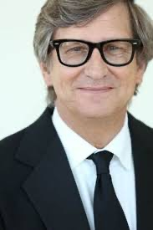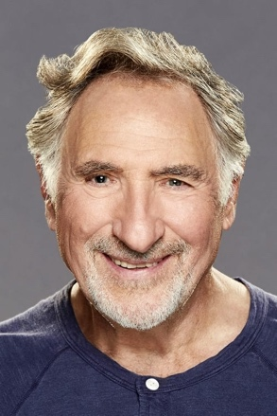
Rick Carter, Judd Hirsch

San Luis Obispo, CA (April 12, 2023) – The 29th Annual San Luis Obispo International Film Festival (April 25-30) announced the honorees for the film festival, taking place later this month, with two-time Academy Award winning Production Designer Rick Carter receiving the festival’s King Vidor Award, and two-time Academy Award Best Supporting Actor nominee Judd Hirsch receiving the Spotlight Award.

Rick Carter will receive the King Vidor Award as a featured part of the Filmmaker’s Award ceremonies on Saturday, April 29, and on Sunday, April 30, Judd Hirsch will receive the Spotlight Award prior to the Closing Night Gala screening of Marvin Samel’s dramatic comedy IMordecai, in which Hirsch stars in the title role, Both ceremonies will take place at the historic Fremont Theater in downtown San Luis Obispo.

San Luis Obispo Film Festival Director Skye McLennan said, “Every year, there is so much anticipation as to who will be the recipients of our King Vidor Award and Spotlight Award. This year, not only do our honorees share achievements recognized by the Motion Picture Academy as winners and nominees, but they also both worked on last year’s The Fabelmans. In fact, this may be the first time SLO Film Fest has had a pair of honorees connected by one of their most recent films. They are both extremely talented--we are excited to celebrate their accomplishments and have them share their stories with the SLO Film Festival attendees.”

RICK CARTER
A Production Designer and Art Director who has had a hand in creating the visual landscapes and worlds for some of the biggest blockbusters and most beloved cinematic masterpieces in recent memory, Rick Carter is often the man behind today’s visionary filmmakers. Carter is a two-time winner of the Academy Award, winning for both James Cameron’s top-grossing mega-hit Avatar (2010), and his historical production design of Steven Spielberg's Lincoln (2013). Carter also received nominations for his work on last year’s auto-biographical film from Spielberg, The Fabelmans, Robert Zemeckis’ Forrest Gump (1994), and Spielberg’s historic epic, War Horse (2012).

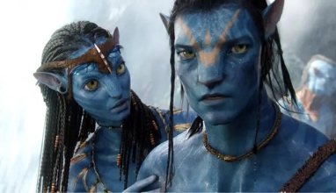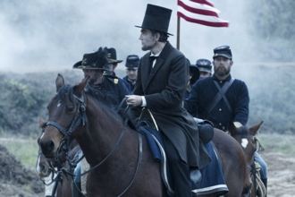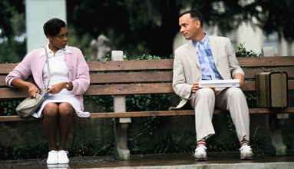
Top: Avatar, Lincoln, War Horse
Bottom: Forrest Gump, The Fabelmans
Carter has also collaborated with Spielberg as a production designer on such diversely set films as The Post (2017), The BFG (2016), Munich (2005), War of the Worlds (2005), A.I. Artificial Intelligence (2001), Amistad (1997), and the blockbusters Jurassic Park (1993) and its sequel The Lost World: Jurassic Park (1997). Carter has also frequently worked as Zemeckis’ production designer. Those collaborations include The Polar Express (2004), Cast Away (2000), What Lies Beneath (2000), Death Becomes Her (1992), and Back to the Future, Part II (1990) as well as Back to the Future, Part III (1989). In a galaxy far away, Carter co-Production Designed Star Wars – The Force Awakens - Episode VII, and Star Wars - The Rise Of Skywalker - Episode IX (2019) with director JJ Abrams.
JUDD HIRSCH
Judd Hirsch has been a singular presence in film, television, and the theater for six decades. He is a two-time Academy Award nominee for Best Supporting Actor, receiving nominations for Robert Redford’s Ordinary People (1980), and last year’s The Fabelmans, breaking the record for the longest gap between Academy Award nominations in history.

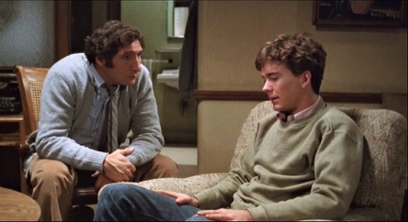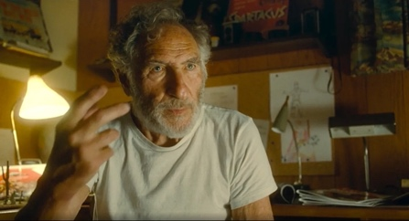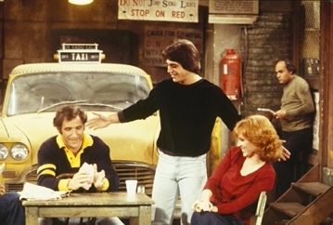
Ordinary People, The Fabelmans, Taxi

He is possibly best known for playing Alex Rieger on the classic television comedy series Taxi (1978–1983), for which he won two Emmys, while also making an indelible impression as John Lacey on the NBC series Dear John (1988–1992), which brought him a Golden Globe award. More recently, he played Alan Eppes on the CBS series Numb3rs (2005–2010). He is also well known for his career in theater and for his roles in films such as Sidney Lumet’s Running on Empty (1988), Roland Emmerich’s Independence Day (1996), Ron Howard’s A Beautiful Mind (2001), Roland Emmerich’s Independence Day: Resurgence (2016), and The Safdie Brothers’ Uncut Gems (2019).

Festival Passes and individual tickets for both nights are now on sale. Information on the film festival can be found at https://slofilmfest.org.

ABOUT SAN LUIS OBISPO INTERNATIONAL FILM FESTIVAL

Located half-way between Los Angeles and San Francisco, San Luis Obispo’s laid-back vibe and serene natural beauty is the perfect setting for this highly regarded annual film celebration. Filmmakers rave about the warmth and attentiveness that is so much a part of the SLO Film Fest experience, as do the swelling tide of industry pros and film critics who are fast discovering the film festival’s thoughtful audiences and unique programming sensibility.

PRESS CONTACT
John Wildman
Wildworks PR
FilmsGoneWild.com
jswildman@hotmail.com
(323) 600-3165

