FOR IMMEDIATE RELEASE

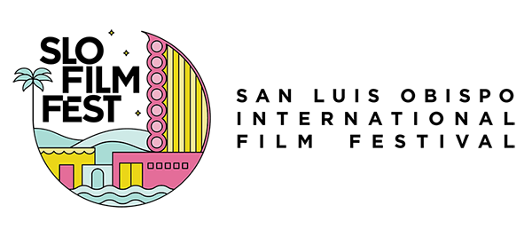

San Luis Obispo International Film Festival Announces 45th Anniversary Screening of Dawn of The Dead

Rarely screened zombie horror classic will be presented in association with local film festival MicroHorrors

(SAN LUIS OBISPO, CA)--The SLO International Film Festival (SLOIFF) has scheduled a special night of tricks and treats for the 30th anniversary of the festival. As part of their “Red Eye Cinema” series, they will screen Dawn of the Dead on Saturday, April 27 at 8:30 pm in association with the founders of MicroHorrors, Katie Neville and Jason Kaiser.

“Over the years we have noticed that we have had a gap in horror and genre programming, which has been extremely successful with our peers and in the independent film world. This is our fourth year of what we call Red Eye Cinema, a new effort to incorporate horror films into the festival through late night screenings,” said Skye McLennan, executive director of SLOIFF. “We've discovered that these screenings are widely popular in San Luis Obispo and often these films can touch on important cultural themes and social issues.”

Celebrating its 45th anniversary, Dawn of the Dead premiered in 1978. Written and directed by George Romero of Night of the Living Dead fame, it was named one of the top cult films by Entertainment Weekly magazine. Its lasting appeal is best summed up by the prominent film critic, Roger Ebert, who wrote in 1979, “Dawn of the Dead is one of the best horror films ever made -- and, as an inescapable result, one of the most horrifying. It is gruesome, sickening, disgusting, violent, brutal, and appalling. It is also brilliantly crafted, funny, droll, and savagely merciless in its satiric view of the American consumer society. Nobody ever said art had to be in good taste.”

"The opportunity to watch this film in a theatre, with fans, has long been an experience that has alluded us (and the masses!),” said Jason Kaiser.
“The film’s presentation of humanity, culture, and consumerism are just as ripe for conversation today as they were upon its release. So join us at The Fremont for a late-night screening at the SLO Film Fest, of George Romero’s seminal sequel—Dawn of the Dead… and then question what you know about being human."

Dawn of the Dead is currently not available on any streaming services, and is rarely screened in theaters, so the inclusion in the festival is a rare opportunity to view this iconic zombie thriller. Tickets for the screening or for SLOIFF can be purchased by visiting https://slofilmfest.org/box-office/

More information about MicroHorrors can be found by visiting https://www.microhorrors.com/

ABOUT SAN LUIS OBISPO INTERNATIONAL FILM FESTIVAL
Celebrating its 30th anniversary in 2024, the San Luis Obispo International Film Festival is a 6-day annual event, showcasing creative, diverse, and impactful works from around the world in a wide variety of venues, from the city’s classic art deco Fremont Theatre, to the vintage Palm Theatre. The 2024 festival will run from April 25-30, Encore, taking place in Paso Robles, is held from May 1-5. Tickets and festival passes can be purchased here.

Located half-way between Los Angeles and San Francisco, San Luis Obispo’s laid-back vibe and serene natural beauty is the perfect setting for this highly regarded annual film celebration. Filmmakers rave about the warmth and attentiveness that is so much a part of the SLO Film fest experience, as do the industry pros and film critics who are fast discovering the film festival’s thoughtful audiences and unique programming sensibility.

# # #

