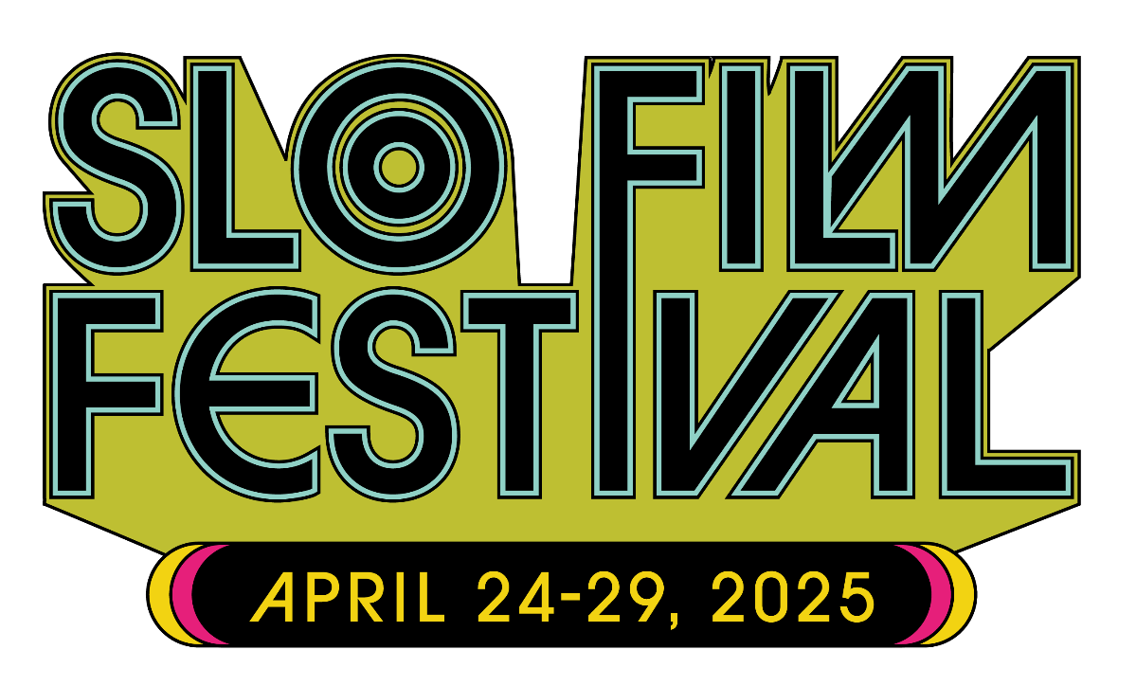

The 2025 San Luis Obispo International Film Festival Announces Opening and Closing Films

The Festival opens with Sundance winner DJ AHMET and closes
with Daryl Hannah’s Coastal

(San Luis Obispo, CA)–San Luis Obispo International Film Festival (SLOIFF) has announced this year’s opening and closing films with 2025 Sundance Audience Award winner DJ Ahmet leading the way, and Daryl Hannah’s documentary on Neil Young’s solo tour, Coastal, as the Closing Night selection.

With a slate of over 113 films including narrative features, short films, documentary features, and doc shorts, the festival offers a broad spectrum of content for serious cinephiles, devoted film buffs, and casual movie fans both locally and across the region. The festival runs from Thursday, April 24 through Tuesday, April 29.

DJ Ahmet, written and directed by Georgi M. Unkovski comes to SLOIFF on Opening Night following its debut at Sundance. The Opening Night Reception at the historic Fremont Theater will kick off the 31st Anniversary Festival. It presents an opportunity to meet special guests, filmmakers, and major contributors, along with catered bites from Luna Red and live music

DJ Ahmet introduces Ahmet, a 15-year-old boy from a remote Yuruk village in North Macedonia, who finds refuge in music while navigating his father’s expectations, a conservative community, and his first experience with love –a girl already promised to someone else. The writer and director, Georgi M. Unkovski, explains, “In DJ Ahmet, I wanted to explore the delicate balance between tradition and self-expression, particularly within a small, close-knit community. The film delves into the challenges of growing up in a traditional setting while simultaneously discovering one’s own identity. At its core, the film is about the universal human need to express oneself, and how art, in this case music, can become both a refuge and a catalyst for change.”

SLOIFF’s Closing Night selection, Coastal, invites viewers to take a journey with maverick musician Neil Young in a personal, behind-the-scenes documentary as he cruises the coast on his recent solo tour. Directed by acclaimed filmmaker and Young’s wife, Daryl Hannah, Coastal offers a glimpse behind the curtain of this unguarded iconoclast, as he navigates a return to the stage post-Covid – from his everyday observations on the bus to his candid, wry banter with his audience. The illuminating film also features songs rarely, if ever, played live, performed in breathtakingly beautiful theaters.

San Luis Obispo International Film Festival Director Skye McLennan said, “We are really excited to open and close the festival with two incredible independent films that celebrate the healing and connective power of music.”
Also on tap at the festival are the fest’s famous Surf Nite, the popular Central Coast Filmmaker Showcase, Cal Poly Short Cuts, and Music Video Showcase. Community of Skate is returning for a repeat performance after a successful debut in 2024.

Additional programs include short films curated by R.A.C.E. Matters, Filmmakers of Tomorrow, featuring short films by those 18 and under, a program curated by The Coastal Awakening celebrating David Lynch and meditation, and new this year, Ecologistics, a series of environmental documentary shorts.

Passes are now on sale and information on the film festival can be found at https://slofilmfest.org.

ABOUT SAN LUIS OBISPO INTERNATIONAL FILM FESTIVAL
Celebrating its 31st anniversary in 2025, the San Luis Obispo International Film Festival is a six-day annual event, showcasing creative, diverse, and impactful works from around the world in a wide variety of venues, from the city’s classic art deco Fremont Theater to the SLO Film Center at the vintage Palm Theatre. Named to MovieMaker Magazine’s “25 Coolest Film Festivals” list, and USA TODAY's 10Best Readers Choice Awards, the 2025 festival runs from April 24-29. SLOIFF is an Academy of Motion Picture Arts & Sciences Qualifying Festival in the category of “Best Documentary Short”. Tickets and festival passes can be purchased here.

Located halfway between Los Angeles and San Francisco, San Luis Obispo with its laid-back vibe and serene natural beauty is the perfect setting for this highly regarded annual film celebration. Filmmakers rave about the warmth and attentiveness that is so much a part of the SLO Int’l Film Festival experience, as do the industry pros and film critics who are fast discovering the fest’s thoughtful audiences and unique programming sensibility.

# # #

PRESS CONTACT
Ann Flower
Ann Flower Communications
ann@annflowerpr.com
310.903.0319

Film images are available here.

